1. Create dataset View_SMartData

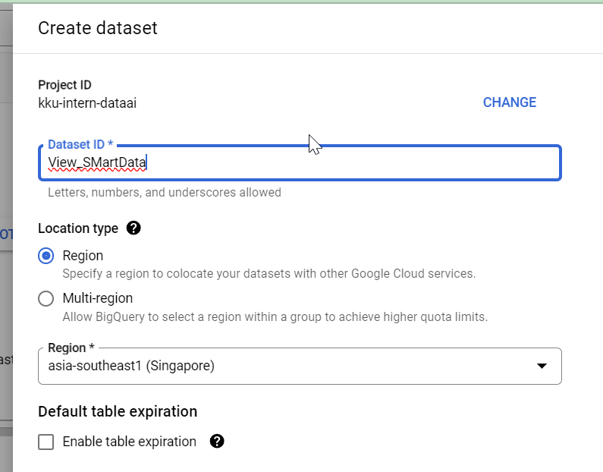

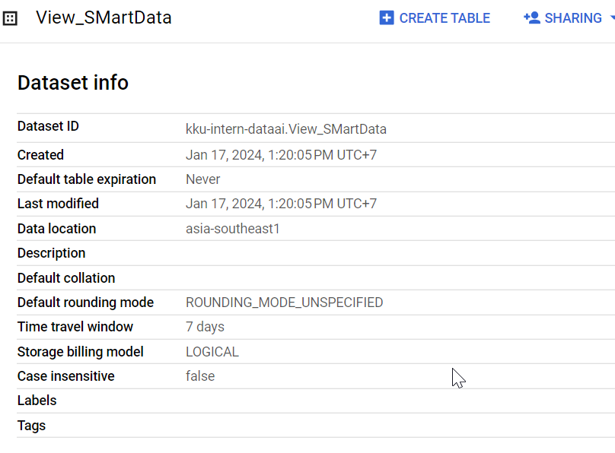

1. Create permission Bigquery User in IAM Project



1. Grant bigquery viewer to x including service accout

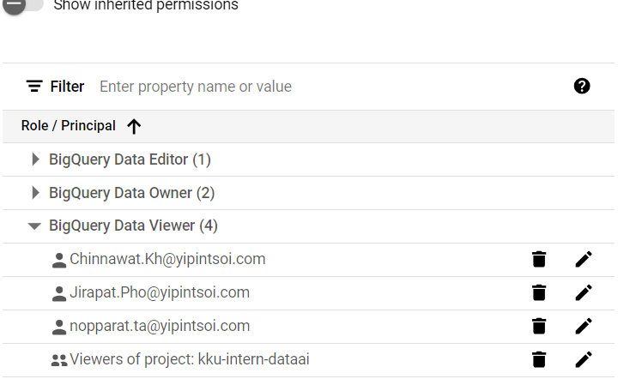

1. Create 4 views project ,inventory,pm_plan,pm_item+incident as below

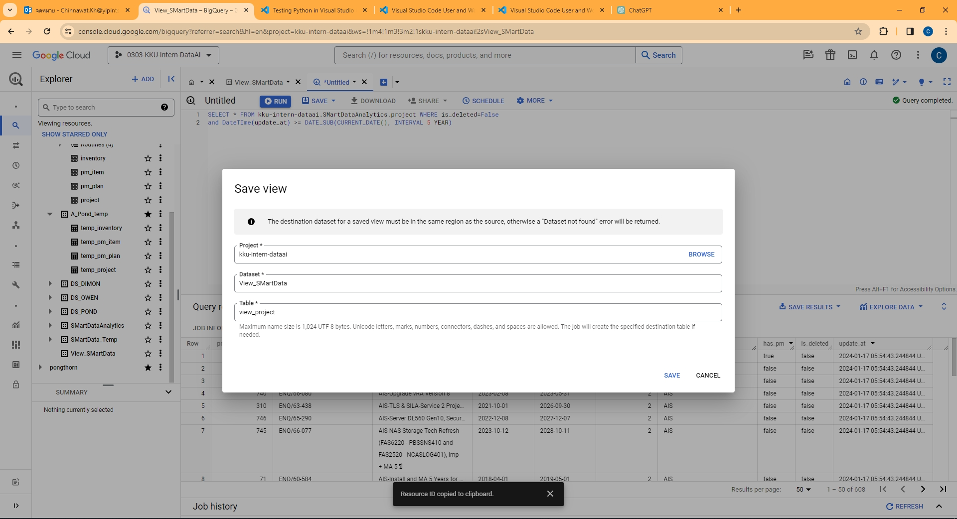

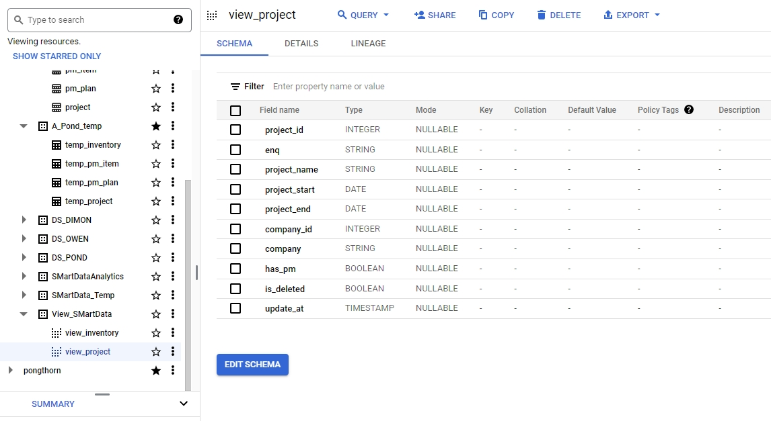

1. set authorized view to source dataset (dataset that you use to create view)

